Sprint 2 – Accuracy Design Document

November 22, 2021

Table of Contents

1. Executive Summary 3

1.1 Project Overview 3

The basis of this project is for the students to properly engage in and work on block code to further operate a Sphero robot. The students will all work together in finding out how to solve the endurance portion of the Robotics Project and get the robot to follow the intended specifications. At the end of the project the students will have developed skills that will enable them to move forward with the next two parts of the Robotics project. 3

1.2 Purpose and Scope of this Specification 3

2. Product/Service Description 3

2.1 Product Context 3

2.2 User Characteristics 3

2.3 Assumptions 3

2.4 Constraints 4

2.5 Dependencies 4

3. Requirements 4

3.1 Functional Requirements 4

3.2 Security 5

3.2.1 Protection 5

3.2.2 Authorization and Authentication 5

3.3 Portability 5

4. Requirements Confirmation/Stakeholder sign-off 5

5. System Design 5

5.1 Algorithm 5

5.2 System Flow 6

5.3 Software 6

5.4 Hardware 7

5.5 Test Plan 7

5.6 Task List/Gantt Chart 8

5.7 Staffing Plan 8

# Executive Summary

## Project Overview

## The basis of this project is for the students to properly engage in and work on block code to further operate a Sphero robot. The students will all work together in finding out how to solve the endurance portion of the Robotics Project and get the robot to follow the intended specifications. At the end of the project the students will have developed skills that will enable them to move forward with the next two parts of the Robotics project.

## Purpose and Scope of this Specification

In scope

* The purpose of this project is to create an application that will enable the Sphero SPRK+ to move along consistently in a figure eight motion five times while switching lights and speaking. This application will give students a more in-depth view on how to program the Sphero SPRK+

Out of Scope

* This application is part two of three in the robotics project. This application, being the second out of the two, will give students a more in-depth view on how to program the Sphero Robot. This application will also be harder as the students must be able to complete the specified program and repeat it five times while staying on the correct figure eight track.

# Product/Service Description

## Product Context

* This program will relate to the other programs necessary to complete the Robotics Triathlon. This program is independent for Sprint 2 but will join two other independent programs to complete all the tasks in the Triathlon. It is interfaced with phones and computers. The diagram below shows how the Sprints are all independent yet interconnected by the Triathlon.

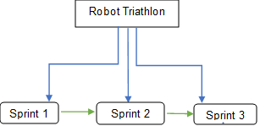

## User Characteristics

* Some of the people that may be using this product include:

Students

Teacher / Professor

Sphero technician

People that have experience using Sphero and block code

Classmates who are comparing codes

## Assumptions

* User has access to a Sphero SPRK+.
* User has downloaded and access to the Sphero application.
* User has access to classroom for robot testing
* User has access to computer to work on Ghant chart and SDD
* User has access to stay after class to work on the project
* User uses time wisely to finish project on time

## Constraints

* Must have enough computer space to store and run the program
* Must be programmed in Sphero
* A device that lacks Bluetooth capability
* Not enough space to effectively test and execute programs
* Group must be able to organize meetings after class time
* Must complete all required documents

## Dependencies

* This new product will require the SPRK+ to follow the figure eight track around the classroom
* The robot must complete all listed requirements
* Groups must be able to effectively communicate
* The group must be able to meet to go over the project and discuss what needs to be completed
* The group must come together in order to solve the problem and figure out how to get the robot to follow the correct code to follow the track around the classroom.

# Requirements

## Functional Requirements

| Req# | Requirement | Comments | Priority | Date Rvwd | SME Reviewed / Approved |
| --- | --- | --- | --- | --- | --- |
| ENDUR_01 | Robot will start in the center of the figure eight | High priority because if not robot is not placed in the center, it will affect the rest of the robot's code | 10/10 | 11/17/21 | Approved |
| ENDUR_02 | Start robot code and follow the circular pattern on the floor | Higher priority as the requirement of this run is to follow the figure eight pattern on the floor | 8/10 | 11/17/21 | Approved |
| ENDUR_04 | Follow the same code just backwards as this will complete the figure eight pattern | Large part of code as the robot needs to stay in an accurate motion in the layout | 8/10 | 11/17/21 | Approved |
| ENDUR_05 | Repeat code five times | Major part of code as a requirement is that the code is followed by the robot five times | 10/10 | 11/17/21 | Approved |
| ENDUR_06 | Ensure that each time robot follows code it stays on track of the layout on the floor | Important as this is the “accuracy” sprint and the whole idea is to run an accurate Robot program | 5/10 | 11/17/21 | Approved |
| ENDUR_07 | After code is run five times make sure it stops in the same spot it started in | Very important as this shows the program followed the correct path | 8/10 | 11/17/21 | Approved |
| ENDUR_08 | Robot will speak “I am the winner” and flash multicolor | High priority as this ensures the program is complete | 10/10 | 11/17/21 | Approved |
|  |  |  |  |  |  |
|  |  |  |  |  |  |

## Security

### Protection

* Program is password protected by group members devices

### Authorization and Authentication

* Program is privately shared by group members and validated in person.

## Portability

This project is highly portable because:

* The use of laptops and phones to write and run code enables work to be done basically anywhere
* The application and code are accessible and executable across multiple operating systems
* No internet access is necessary to complete this project
* The SPRK+ is highly portable due to its size
* SPRK+ could be run in almost any indoor environment

# Requirements Confirmation/Stakeholder sign-off

|  |  |  |
| --- | --- | --- |
| Meeting Date | Attendees (name and role) | Comments |
| 11/17/21 | Julia (leader), Jolie (programmer), and Ryan (recorder) | confirmed all |

# System Design

## Algorithm

1. Have SPRK+ spin forward 360 degrees for 12 seconds at a speed of 40 to move around the entirety of one of the circles clockwise.
2. Reverse SPRK+ so that is goes forward –360 degrees for 12 seconds at a speed of 40 around the other circle counter clockwise.
3. Repeat steps 1 and 2, four additional times.
4. Stop SPRK+.
5. Have the SPRK+ speak “I am the winner”
6. Flash multicolored lights for 5 seconds by having the light change from blue to pink, then green to yellow, then orange to red. Repeat this step one additional time.

## System Flow

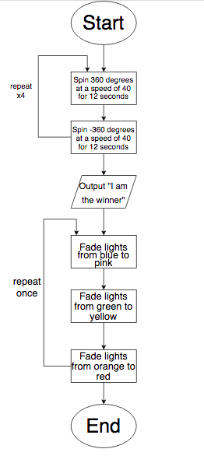

## Software

Our robot was programmed in Sphero using block code. Below is an image of our sprint 2 block code program along with the sensory data collected after executing the program. The software platform that was used to develop this robotic application was Sphero. This is an online application which enables users to use block code to test out how the robot follows the track around the classroom. This user-friendly program allows the users to simply drag and drop block code and test the code in a less complicated way in comparison to other programming languages. The Sphero application enables the user to understand the basics of programming easily while accomplishing whatever task is at hand. For example, we were able to change the color of the SPRK+’s light by simply using a color wheel; however, if we used a different programming language, we might have had to spend more time trying to figure out the hexadecimal value for the color we needed to use.

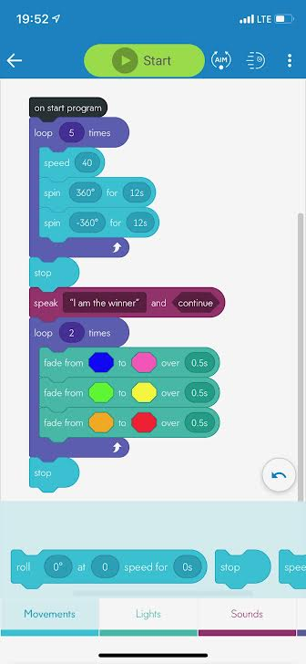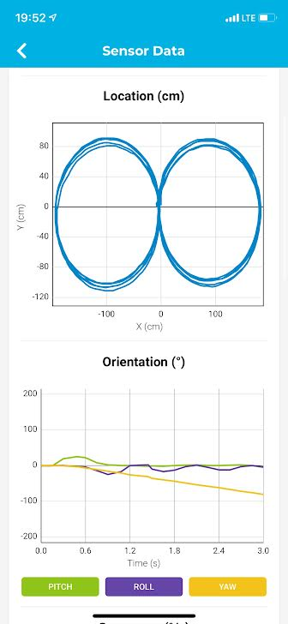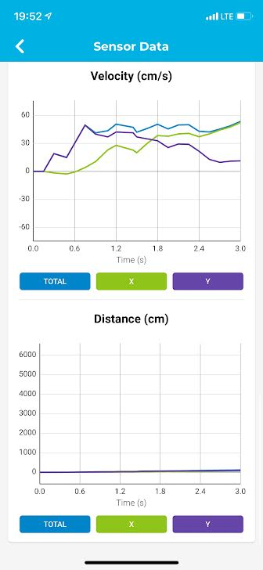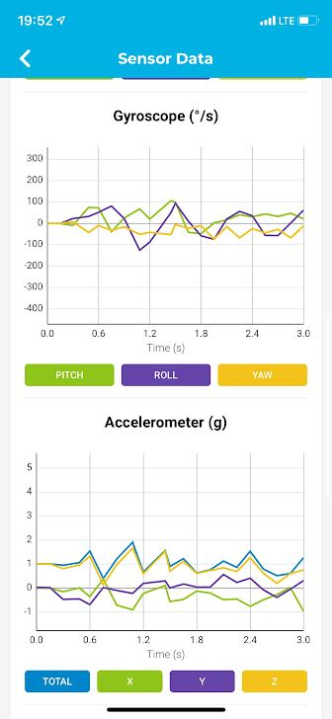

## Hardware

The hardware that we used to undergo this Robotics project was our cell phones or computers. The hardware makes the software an easy-to-use application and helps with the overall programming of the block code. We found that using the computer to code was easier to navigate, but using the phone allowed a more accurate aiming of the SPRK+ because we could move the dial used to aim more precisely. The computer program made this project successful with developing, testing and finalizing the code. We used Sphero SPRK+ to execute our code. We used a cellphone to record the robot video during our demonstration.

## Test Plan

| **Reason for Test Case** | **Test Date** | **Expected Output** | **Observed Output** | **Staff Name** | **Pass/Fail** |
| --- | --- | --- | --- | --- | --- |
| Have SPRK+ complete a full circle clockwise | 11/17/21 | Observe SPRK+ move quickly, yet steadily on the tape circle clockwise. | SPRK+ moved too quickly around circle and did not stay on the tape outline. | All Staff | Fail |
| Have SPRK+ complete a full circle clockwise | 11/17/21 | Observe SPRK+ move quickly, yet steadily on the tape circle clockwise. | SPRK+ moved steadily and precisely on the tape circle, clockwise. | All Staff | Pass |
| Have SPRK+ reverse direction and complete a full circle counterclockwise | 11/17/21 | Observe the SPRK+ move at a steady pace and complete a full circle counterclockwise along one tape circle. | The SPRK+ moved too slow and did not follow the lines of the tape. | All Staff | Fail |
| Have SPRK+ reverse direction and complete a full circle counterclockwise | 11/17/21 | Observe the SPRK+ move at a steady pace and complete a full circle counterclockwise along one tape circle. | The SPRK+ moved too quickly and did not follow the lines of the tape. | All Staff | Fail |
| Have SPRK+ reverse direction and complete a full circle counterclockwise | 11/17/21 | Observe the SPRK+ move at a steady pace and complete a full circle counterclockwise along one tape circle. | The SPRK+ moved at a moderate pace around the second circle counterclockwise along the tape outline. | All Staff | Pass |
| Reuse the code and speed for the first and second circle of the figure eight and repeat 5 times. | 11/17/21 | Observe the SPRK+ remain within the lines of the tape, while following the lines of the figure eight. | The SPRK+ was moving a bit too slowly and began to stray off the tape lines after the first figure eight. | All Staff | Fail |
| Reuse the code and speed for the first and second circle of the figure eight and repeat 5 times. | 11/17/21 | Observe the SPRK+ remain within the lines of the tape, while following the lines of the figure eight 5 times. | The SPRK+ went around the figure eight five times while staying within the tape lines. | All Staff | Pass |
| Have the SPRK+ stop at the same spot in the center, that it started at. | 11/17/21 | Observe the SPRK+ stop at the exact spot in the center of the figure eight that it began. | The SPRK+ stopped a little too far to the left of and a bit passed the ending spot. | All Staff | Fail |
| Have the SPRK+ stop at the same spot in the center, that it started at. | 11/17/21 | Observe the SPRK+ stop at the exact spot in the center of the figure eight that it began. | The SPRK+ stopped exactly at the center spot where it had initially begun. | All Staff | Pass |
| Have the SPRK+ speak “I am the winner” | 11/17/21 | Observe the SPRK+ speak “I am the winner” | The SPRK+ spoke “I am the winner” | All Staff | Pass |
| SPRK+ will flash multicolored lights for 5 seconds | 11/17/21 | Observe the SPRK+ flash multicolored lights for 5 seconds | The SPRK+ flashed multicolored lights for 5 seconds | All Staff | Pass |

## Task List/Gantt Chart

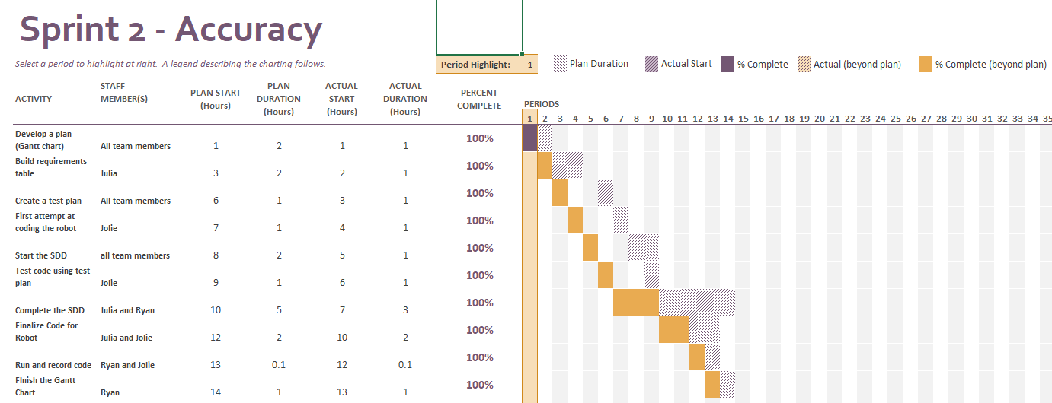

## Staffing Plan

| Name | Role | Responsibility | Reports To |
| --- | --- | --- | --- |
| Ryan | Recorder | Organized Gantt chart, SDD | Julia |
| Jolie | Programmer | Runs block code. Oversees the robot video and flowchart, SDD. | Julia |
| Julia | Leader | Manages GitHub repository, SDD, ensures all parts of project are completed. | Julia |